**Market Research: Apple Maps**

*Group 9: Arthur De Wolf, Alexander Tran, Akshaya Ramprasad, Nivedya Manikandanpillai*

**Q1) Conduct secondary research covering background information on the business you have selected. Describe the company, product, pricing, and several competitors. What makes this company different from its competitors?**

**(Product)** Apple Maps is a commonly used navigation app that was put together by Apple in 2012. They offer users a variety of features to aid in locating a destination for travel.

**(Pricing)** The service has been and is still free for all apple users and can be used as long as the user has an apple device in their possession. **(Competitors)** This market is quite competitive, there are many other businesses, small to large, that offer such services, including Google Maps, Waze, HERE WeGo, MapQuest, and many others. Google Maps currently dominates the mobile maps market with an 80% market share, and Apple Maps is right behind them with 10-12% of the market share. **(Value Proposition)** What makes Apple Maps unique is their cleaner interface, which is appealing to the eyes of users. Another important difference with the competition is that Apple Maps makes an emphasis on data privacy, unless the user opted-in to data sharing. Apple maps give users options to delete their data, unlike Google Maps where they advertise suggested locations to visit based on historical search data. Even though apple maps had a rough start (Tim Cook, Apple CEO even made a public apology for bad user experience), it made lots of updates and significant investments over time, and their product now matches google maps in terms of features and value.

**Q2) Identify the management/business problem or opportunity that you feel needs to be managed. Put yourself into the "shoes of the decision-maker" and identify symptoms. Do secondary research and supply charts and graphs supporting the symptoms you have identified.**

1. Customer Satisfaction
2. Low market share

Apple maps is currently facing some symptoms, they are struggling to gain market share over google maps. They are the 3rd biggest player industry, but only have 11% of the market share while google maps has over 67%. A manager at Apple should ask themselves if consumers are not satisfied with apple maps.

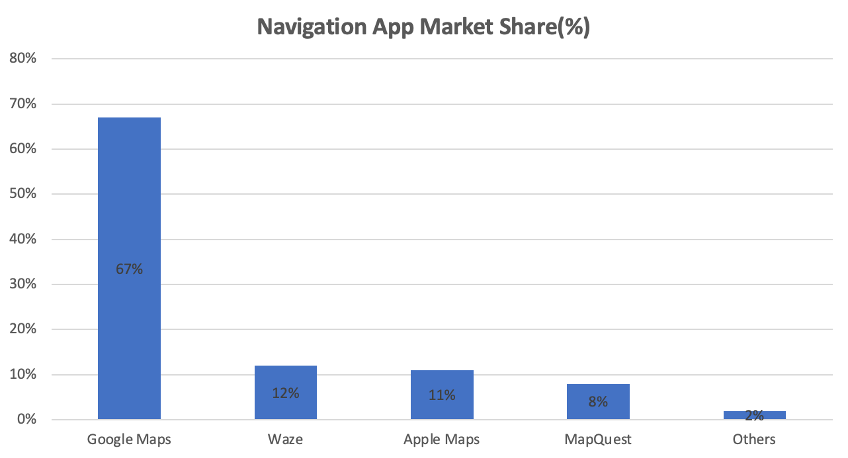

Source:The Manifest,RBC Capital Markets

1. Low active users

Apple maps’ user base is as well lower than its main competitor. According to the chart below, in 2019, Google maps also has 154.4 million active users each month whereas apple maps has only 23.3 million.

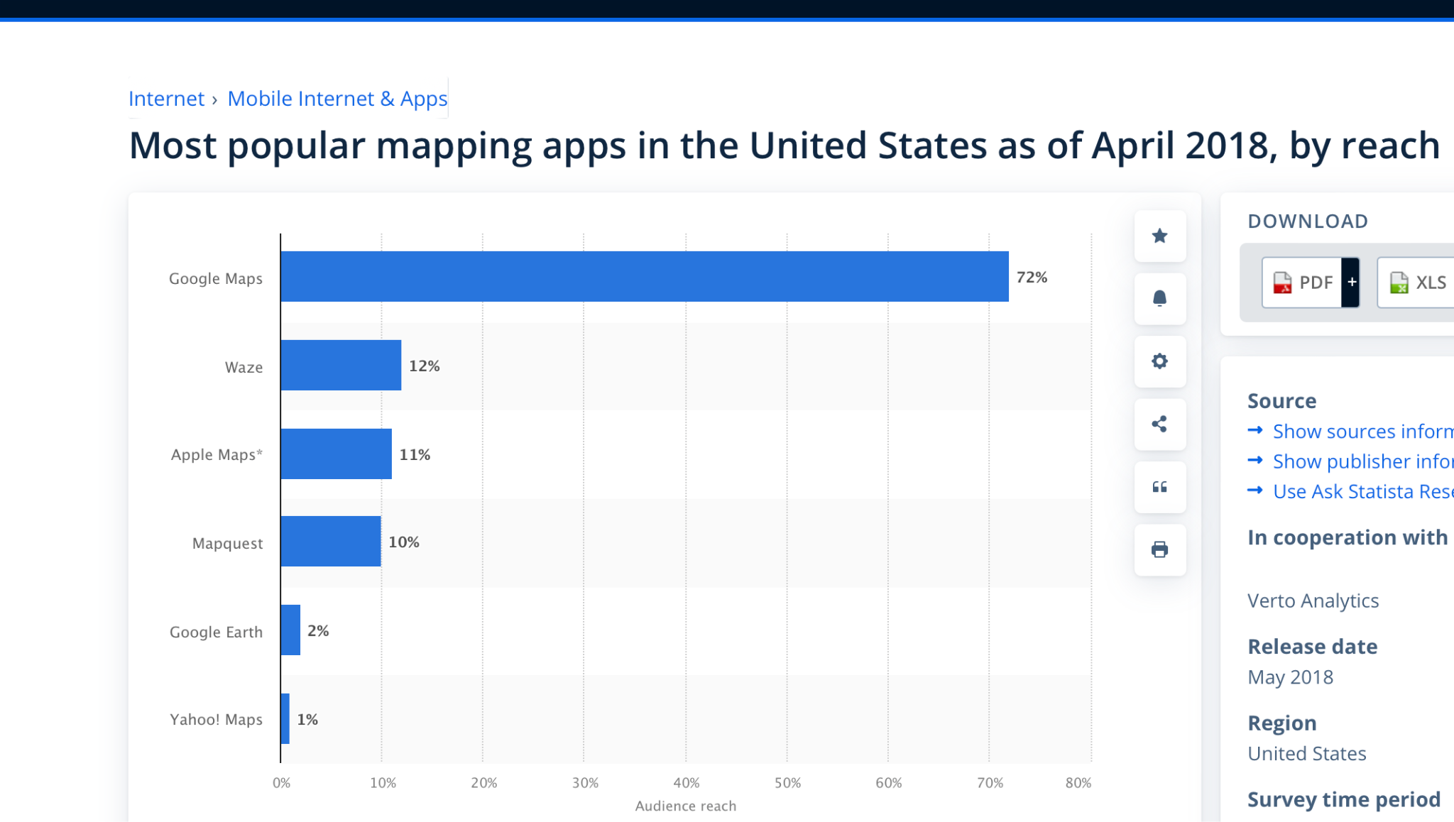

*Most Popular Mapping apps in the US (April 2018) by reach (Source: Statista)*

**Marketing Management Problem:** Apple maps fails to gain market share over its competitors.

**Next, translate the management problem into a marketing problem/issue or hypothesis. Identify causes. Use a marketing framework and select a marketing problem that you believe needs to be researched in terms of managing/fixing the business problem. For example, possible options may be either a customer satisfaction issue or a product development issue. Discuss the marketing management problem and discuss why the marketing research information you will be collecting will help solve the problem. Please use textbook references in support of your marketing problem.**

One possible reason why apple maps face this management problem could be related to customer satisfaction. After carefully conducting research, we found out that apple maps could be underperforming in terms of features and performance compared to the competition. All of this could be leading customers to be dissatisfied with apple maps and switch to google maps.

**(1)** Google maps has a greater database of geographic and crowd sourced data and is technically more reliable when calculating commutes and travel plans. As you can see in the Image below, google maps shows more routes and small paths compared to apple maps.

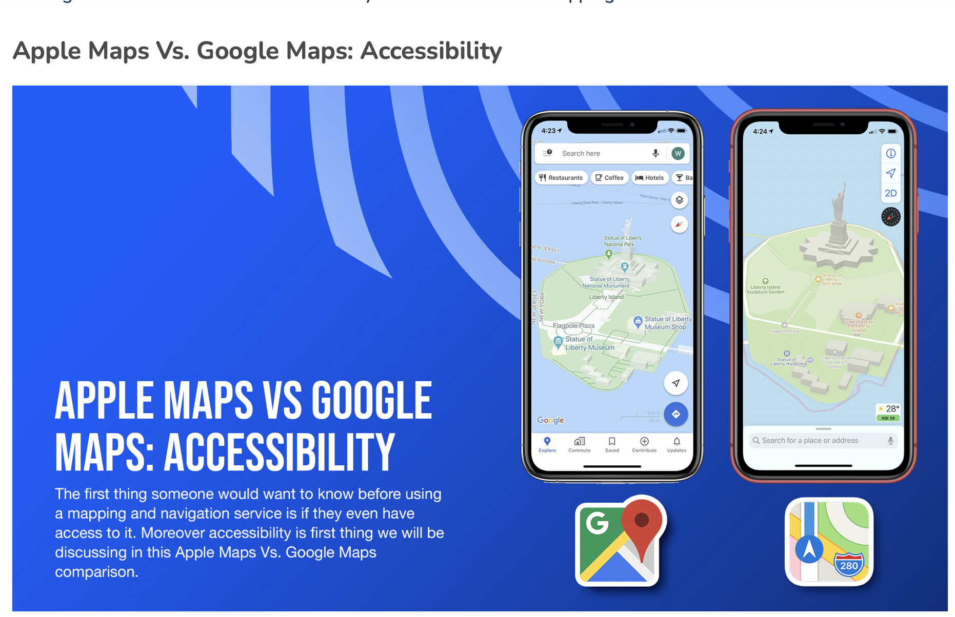 (2022 - [source](https://agilestorelocator.com/blog/apple-maps-vs-google-maps-comparison-guide-2022/))

**(2)** The interface useability is lacking behind competition. Google contextualizes effectively by informing us when it will open but with regards to Apple maps, it will provide you their complete business hours, but that information is harder to access as it is hidden behind some scrolling and clicking.

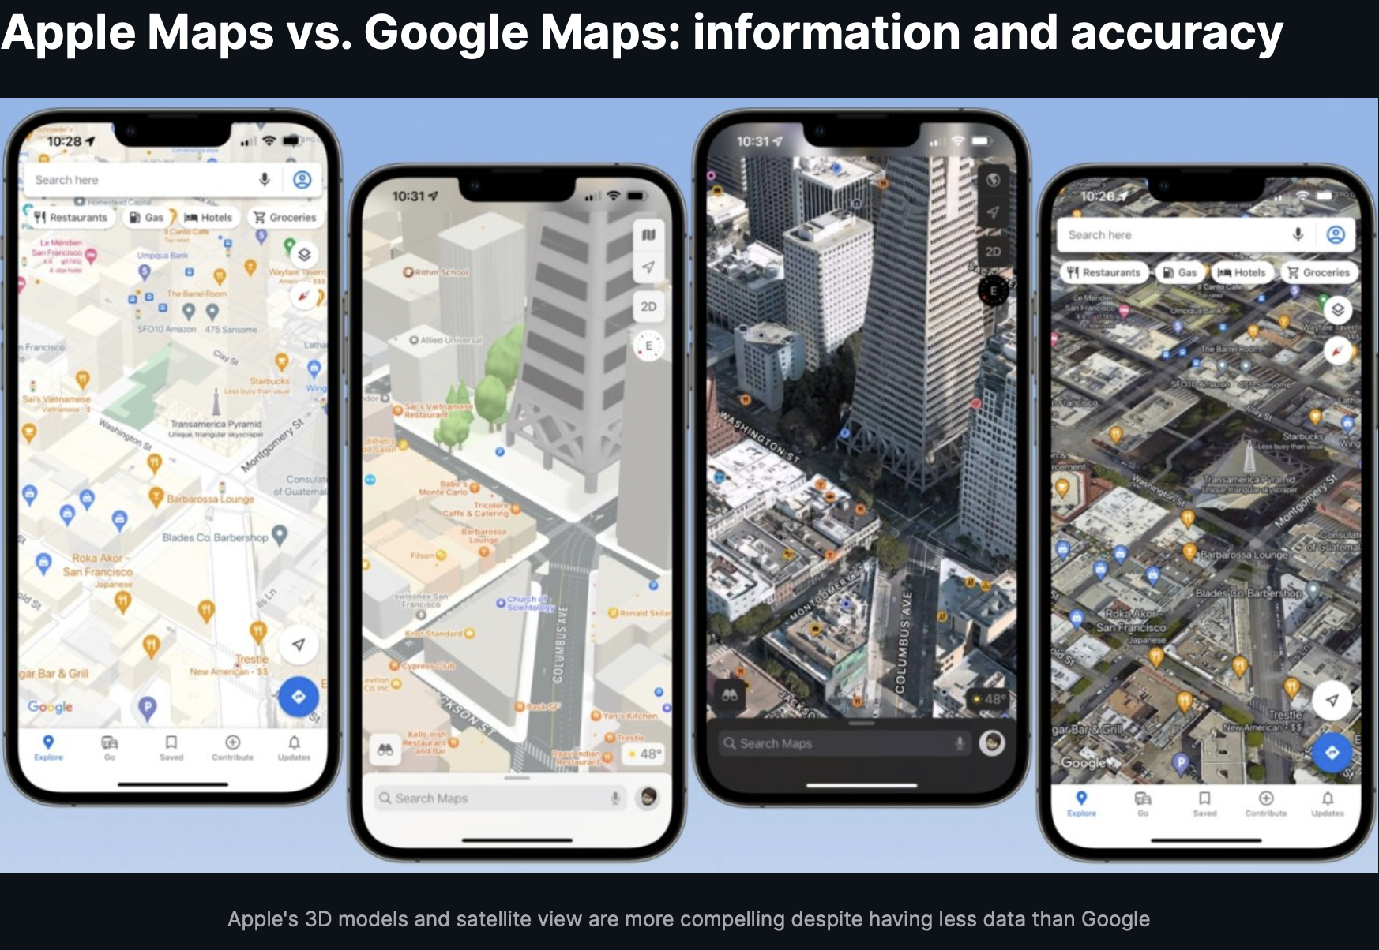(2022 - [source](https://agilestorelocator.com/blog/apple-maps-vs-google-maps-comparison-guide-2022/))

Those reasons could in part explain why apple maps has such a low market share and low user base compared to google maps, we could therefore question the value of apple maps vs google maps in terms of product quality.

By researching information from customers, we can expect to have a better understanding of customer satisfaction towards apple maps features. Conducting further research on customer satisfaction will help us confirm or reject our hypothesis, which is the following: **Customers are unsatisfied with current apple map service, which prevents them from gaining new customers.**

**Translate the marketing problem into a list of marketing research objectives. These objectives must be specific, measurable, and actionable (use bullets when describing your research objectives) and related to the marketing problem you will be investigating. For instance, think of what you will want to know and ask consumers to describe and diagnose solutions to a customer satisfaction or product development marketing problem. What sources did you use?**

**Marketing Research Objectives: What will you measure in a customer satisfaction study?**

* We want to know the preference of iphone users regarding navigation apps,
  + Specific
  + Measurable
  + Actionable
* What features do iPhone users look for in a navigation app?
* How does an iPhone user feel about the current features offered by apple maps?
* What features could apple maps develop that iphone user potentially adopt?
  + Compare apple map user and google map user in terms of loyalty
* How is Apple maps perceived? What are consumers' expectations in terms of features? What would they like to see that’s new/innovative?
  + What features are essential to consumers?
  + Propose a set of features in a question and see which are more important to consumers?
* The most common issues on apple maps? How does Apple address it?
* What actions can Apple take to reach most of the users (Mac and Non mac users)?
* Is Apple Maps failing because of a usability issue? Or because they fail to convince consumers it is worth using? -> Is it a customer perception problem or rather the service itself?

**Sources:**

* <https://www.forbes.com/sites/petercohan/2012/09/27/apple-maps-six-most-epic-fails/?sh=5ef80747df9d>
* <https://www.zdnet.com/article/apple-maps-vs-google-maps/>
* <https://www.wsj.com/articles/apple-maps-app-popularity-iphone-8e52aec1>
* <https://groups.google.com/>
* <https://appleinsider.com/articles/22/05/13/compared-apple-maps-versus-google-maps-in-2022>
* <https://techpp.com/2022/12/09/how-to-use-apple-maps-on-android-and-windows/>
* <https://www.theverge.com/23323550/apple-maps-10-year-anniversary-iphone-google>
* <https://agilestorelocator.com/blog/apple-maps-vs-google-maps-comparison-guide-2022/>

Ques: 3 or 4 marketing information objectives for a customer satisfaction study of customers using Apple maps?how to conceptualize and measure customer satisfaction?

Analyze Apple Maps' general usability and layout to **determine how users engage** with the program, spot any interface flaws, and get input on user interface enhancements. To measure it conducts users' interviews, evaluations of usability, and surveys for collecting qualitative and quantifiable data on how users feel about the interface, how simple it is to use, and how well it facilitates navigation.

**Recognize feature needs and preferences:**  Identify user-important features and functionalities and look at areas that could use enhancement. Implement surveys or hold focus groups to learn more about the features that users like and wish were available. Examine user comments and reviews made on social media and app stores to find recurrent feature requests or grievances. • Metrics: Top features, user ratings for individual features, and user-generated feature suggestions.

**Customer advocacy and loyalty metrics:** Assess Apple Maps customers' loyalty and propensity to refer other people to the platform. Use the Net Promoter Score, or NPS, approach to calculate the probability that consumers will recommend Apple Maps. Keep an eye on internet forums and social media mentions about Apple Maps to determine support and mood. The Net Promoter Score (NPS), sentiment analysis of social media, and user comments and reviews.

**Part 2: Study Design and Material**

A 2-3 page paper describing your study’s measurement process and sampling strategies. This part of the project must:

**(1) Describe the sampling frame (population) clearly and distinctly.**

Our sampling frame will be our friends and family, as well as students from CSULB. This is a non-probability design, so we will be using a convenience sampling frame to obtain our data. There will not be any sampling error because we are not using a probability design for our samples. We do not have access to the total population, so contacting friends, family, and CSULB students will be used for our research.

**(2) Select and describe the sampling strategy you’ve selected (i.e. simple random, convenience, etc.), discuss why you selected this sampling strategy, and discuss the strengths and weaknesses of your selected sampling strategy using references to text and lecture materials.**

**Selection and Description:** For the purpose of this study, we will be using convenience sampling. Convenience sampling is one of the nonprobability sampling techniques that relies on convenience, rather than selecting samples using randomization and probability sampling. We choose to go with convenience sampling because of its affordability and practicality, and because it should give us sufficient information to perform exploratory research regarding apple maps' limited usage.

**Strengths:** Convenience sampling is effective, it saves time and resources. As our sample group consists of friends and family, we will be able to gather information quickly and at no cost.

**Weakness:** The results we will gather from our survey will not be fully representative of the population. The most significant problem would be sampling bias. Friends tend to have the same opinions, therefore the data collected through the convenience sampling strategy might not be accurate. Also, since the sampling is based on a very limited population, we may not capture diverse perspectives or experiences.

**(3) Describe your data collection method(s) (i.e. intercept, internet surveys, etc.) and describe the step-by-step interviewing procedures you will be using. Then explain the strengths and weaknesses of your selected data collection method using references to text and lecture materials.**

**Internet survey** will be used for collecting information about Apple map users' satisfaction. We will use Qualtrics to create/design the survey.

**Designing the survey**

By specifying the goals which is to analyze customer satisfaction, behavior, and preferences of Apple map users and creating a questionnaire with well-structured, precise questions. Additionally, we make sure that the questionnaire is simple to use and accessible online. We have assigned participants during the survey about 5-8 minutes to finish as part of the data gathering process. We are aware that participants frequently have busy schedules and short focus periods, so we chose a 5-8 minute questionnaire time frame to strike an equilibrium between learning as much as possible about respondents and being considerate of their time limitations. The questionnaire will consist of 20 well-constructed questions that are intended to effectively capture a broad range of viewpoints and ideas on customer satisfaction. These inquiries address both precise details and broader views in order to achieve a full comprehension of the subject. Because of their large user bases and popularity, platforms like LinkedIn, Instagram, and Facebook are ideal for successfully connecting with our target audience.

**Sampling**- Our target population are iPhone users between the ages of 21 to 40, as this population is the most likely to drive a car to work or go on a trip where they use navigation applications. As introduced previously, we will be using convenience sampling for our research. In order to reach our sample we plan on creating an online survey that we will distribute via social media platforms.

It's vital to recognize that this technique may bring biases into the findings because participants selected by the investigator might not accurately reflect the population as a whole.

**Inviting Participants**: We will be sending invitations to our individual network of friends, professionals, and family through the use of social media. We will either create a story or post on our social media that will briefly mention the purpose of the research, provide a link to a survey and gently ask for people to take the survey. Social media platforms will include Linkedin, Instagram, and Facebook. We also make sure that participation is voluntary, anonymous, and private. For instance, platforms such as Tiktok are not suitable for sending questionnaires because the user is a younger population and the interface is not appropriate for sharing data. If more data is needed, we can also print out a paper that briefly mentions the purpose of the research as well as a QR code that links to the survey that we would hang around campus.

**Strengths of Internet Surveys:**

Internet surveys may have wide access and reach a broad and diverse population across the LA and OC area, making it a practical choice for gathering information from a significant number of people at a reasonable cost. Internet surveys can be done promptly, and data can be collected in a small amount of time, enabling quick analysis. When the identities of respondents are safeguarded through the condition of being anonymous., they could feel more at ease giving honest and open answers.

**Internet surveys have the following drawbacks:**

The sample could be skewed if respondents who are unable to access the internet or who are not using the online platform are excluded. Online surveys usually only receive a small number of replies due to format constraints, which could omit significant findings. Contrary to in-person interviews, researchers are unable to obtain further information or ask clarifying questions, which affects our ability to completely understand what participants say. The target population will be unfairly depicted in the survey if participants choose not to reply.

**(4) Finally, explain probability and non-probability sampling and discuss how this pertains to your study design and your research conclusions.**

Probability sampling is a sampling technique where each respondent has a known probability of being selected for an interview. Examples include simple random sampling, proportionate and disproportionate sampling along with others. The advantages of this method are that it is, if done correctly, very representative of the reality, which means that your survey findings can very well represent the whole population studied, however it is a very costly method as multiple processes are involved, such as stratifying the population in groups which requires expensive studies if few data is available.

On the other hand, non-probability sampling is a sampling technique that does not involve a known probability for the survey respondent to be selected. It is a much easier technique compared to probability sampling ones as you can select respondents based on your own judgment, by convenience and others. Very little information is therefore required before identifying the sample to study, if you work at a bakery and wish to test your new cake before selling it, then you could ask friends and family to do so for example. Because non-probability sampling techniques don’t require much information and rely more on the researcher, it is much less costly then probability sampling. It is however not really representative of the population as a whole. If we were to resume both, we could argue that probability sampling techniques are great for conclusive research while non-probability sampling ones are a great fit for exploratory research.

As seen in previous sections, we decided to go with a non-probability sampling technique as we do not have the resources required to perform a probability sampling technique. If we were to do so, we would need to either get a list of all iphone users and then use a simple random sampling strategy, but getting our hands on such data is close to impossible. If we considered doing a stratified sampling technique then we would have to get the list of Iphone users and their demographics which seems even less realizable.

By choosing a non-probability sampling technique such as convenience sampling, we can interview friends and families who own iPhones throughout our social media platforms or in person. Because we choose to go with this approach, we have to keep in mind that the information we gather will be exploratory and will allow us to reinforce our hypothesis, but it would be risky to make business changes based on that information as it might not be representative of the population. But we have to start somewhere!